**Intan Ephys Analysis Optimization**

A Documentation presented

by

Baihan Lin

to

Olavarria Lab

Department of Psychology

in partial fulfillment of the data analysis task

in the subject of

Computational Neuroscience

University of Washington

Seattle, Washington, USA

Apr 2016

**Mentors:**

Dr. Adrian Andelin

Prof. Jaime Olavarria

**Author:**

Baihan Lin

**Abstract:**

The thesis is given birth due to the need to analyze a set of data and the curiosity of finding the best way to generate and present the result, and to simplify the entire Ephys analysis in a paper publication standard.

**Comment:**

This documentation is mainly for the purpose of recording my thoughts and attempts in optimizing the data analysis task, therefore not in a standard of submission in any kind.

**Keyword:**

Matlab, Mac Terminal, Ephys Experiments

**Contents:**

**Abstract …………………………………………………………………………………. 2**

**Keywords ……………………………………………………………………………….. 2**

1. **Traditional Solution:** (Challenges Faced)……………. ………………………….…**5**
   1. Darking/Contrasting Process
   2. Utilization of Gaussian Blurring via ImageJ or Photoshop
   3. Arbitrary Drawing of line in the V1

1. **Task 1: Indicating Patch Index** (Java, ImageJ, MatLab, Patch Analyst) ……….. ...**6**
   1. Solution 1: Implementing the traditional (via Java or MatLab)
   2. Solution 2: Patch analysis via Patch Analyst (New possible alternative)
   3. Solution 3: Particle analysis via ImageJ (New possible alternative)
   4. Solution 4: width of line (Improvement on traditional)
   5. Solution 5: Cluster Index (New possible alternative)
   6. Solution 6: Machine Learning (New possible alternative)
2. **Task 2: Optimizing the data:** (ImageJ, Excel, Java, MatLab)…………………...... **9**
   1. Standardization
   2. Smoothing Method (Moving Average):
      1. Excel (Exploration)
      2. Java (Implementation)
      3. MatLab (Outlook)
3. **Task 3: Systematization:** (systematize the protocol more efficiently) …………….**13**
   1. Automatic file reading and processing
   2. Visual user-friendly version
   3. Automatic software operation
   4. Patch Processor (a Software designed by Baihan Lin)
4. **Method Validation** ………………………………………………………………... **22**
5. **Future Improvements** ……………………………………………………………. **23**
6. **Data Summary** …........................................…………………………………….... **24**
   1. Data Charts
   2. Excel Smoothing Plot (as an indication of the validity of SF = 10/364)
   3. ImageJ Plots & Lines (line & line with width of 100)
7. **Code Summary** (20 Java programs)…….………..………………...…………….. **33**
   1. **First Attempt** (using TreeMap)
      1. MapPatchIndexMain.java (main method)
      2. MapPatchIndexSolver.java (subprogram)
   2. **Better Solution** (using ArrayList)
      1. PatchIndexMain.java (main method)
      2. PatchIndexSolver.java (subprogram)
   3. **Smooth Factor Finder** (test different smooth factor to find the most proper)
      1. SmoothPatchIndexMain.java (main method)
      2. PatchIndexSolver.java (subprogram)
   4. **Automatic System** (read-all files in a folder)
      1. AutoPatchIndexMain.java (main method)
      2. PatchIndexSolver.java (subprogram)
   5. **Attempt to visualize** (output the system console, failed)
      1. AutoPatchIndexMainBackUp.java (main method)
      2. PatchIndexSolver.java (subprogram)
      3. ConsoleTextArea.java (subprogram)
      4. LoopedStreams.java (subprogram)
   6. **Second Attempt to visualize** (user-friendly, using acm.jar and JComponent)
      1. VisualPatchIndexMain.java (main method)
      2. VisualPatchIndexSolver.java (subprogram)
   7. **Standard Java File** (standardize, exportable to jar, then to exe)
      1. VisualPatchProcessorMain.java (main method) with jar/exe
      2. VisualPatchIndexSolver.java (subprogram)
   8. **Version 2.0** (with excel export, smooth factor and imageJ functions, browse)
      1. VEPatchProcessorMain.java (main method) with jar/exe
      2. ExcelFileDealer.java (subclass)
      3. PISolver.java (subclass)
      4. ImageJ.java (revised subclass)

**Bibliography ………………………………………………………………………..... 130**

**Special Acknowledgement …...…………………………………………………….... 131**

**Traditional Solution:**

**(Challenges Faced)**

To determine the patchness, the operational definition might be the patchy darkness difference appeared on V1 of ipsi and contra cortices after tracer injected and HRP reaction. Therefore using ImageJ plot profile is the most approachable choice.

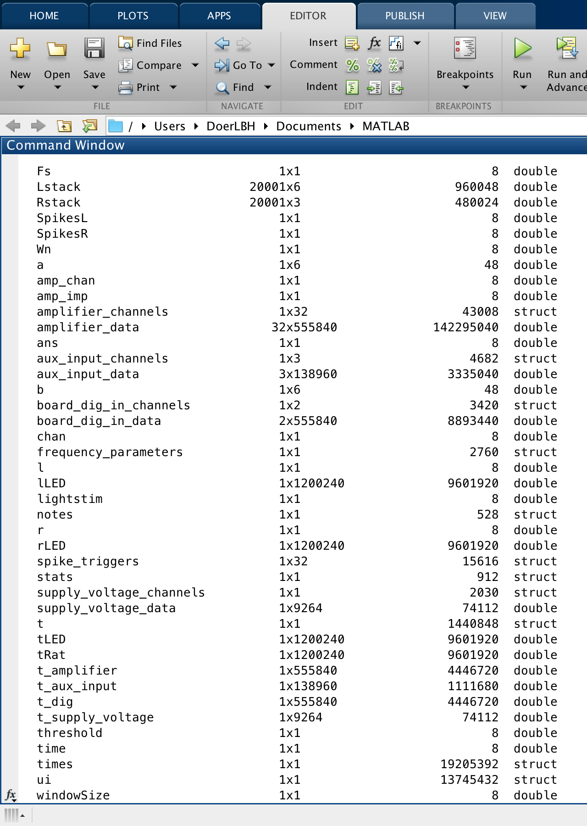

Fs

Lstack

Rstack

SpikesL

SpikesR

Wn

a

amp_chan

amp_imp

amplifier_channels

amplifier_data

ans

aux_input_channels

aux_input_data

b

board_dig_in_channels

board_dig_in_data

chan

frequency_parameters

l

lLED

lightstim

notes

r

rLED

spike_triggers

stats

supply_voltage_channels

supply_voltage_data

t

tLED

tRat

t_amplifier

t_aux_input

t_dig

t_supply_voltage

threshold

time

times

ui

windowSize

amplifier_channels 1x32 43008 struct

amplifier_data 32x555840 142295040 double

aux_input_channels 1x3 4682 struct

aux_input_data 3x138960 3335040 double

board_dig_in_channels 1x2 3420 struct

board_dig_in_data 2x555840 8893440 double

frequency_parameters 1x1 2760 struct

notes 1x1 528 struct

spike_triggers 1x32 15616 struct

supply_voltage_channels 1x1 2030 struct

supply_voltage_data 1x9264 74112 double

t_amplifier 1x555840 4446720 double

t_aux_input 1x138960 1111680 double

t_dig 1x555840 4446720 double

t_supply_voltage 1x9264 74112 double

amplifier_data 32x555840 142295040 double

aux_input_data 3x138960 3335040 double

board_dig_in_data 2x555840 8893440 double

supply_voltage_data 1x9264 74112 double

t_amplifier 1x555840 4446720 double

t_aux_input 1x138960 1111680 double

t_dig 1x555840 4446720 double

t_supply_voltage 1x9264 74112 double

%% Begin with opening file to be analyzed

clear all %Starting a new analysis so we want to eliminate all old variables

close all

%

%First we import the data using:

%read_Intan_RHD2000_file = Opens the Matlab file browser UI to locate the

%file of interest. Afterward it reads header info and establishes basic

%variables from the .rhd file

%

read_Intan_RHD2000_file

%

%From function info: % Reads Intan Technologies RHD2000 data file generated by evaluation board

% GUI. Data are parsed and placed into variables that appear in the base

% MATLAB workspace. Therefore, it is recommended to execute a 'clear'

% command before running this program to clear all other variables from the

% base workspace.

%check what variables have been imported, especially if youre unsure

%whether accessory amplifier channels were disabled or not during recording

%% Establishing some basic variables from values pulled in by above function

amplifier_channels(1) %Channel data is being collected on (on

%preamplifier this would be 'A-004'

%Above command gives data output about the channel on which data is being

%collected

%% Variable name changes below to simplify:

tRat = t_amplifier; %time variable for ephys data

tLED = t_dig; %time variable for LED data

ui.ratData = amplifier_data(1,:);

lLED = board_dig_in_data(1,:);

rLED = board_dig_in_data(2,:);

% %% Check variables look right-- plot should be identical to last one

% figure % for spike detection

% hold on

% plot(tRat, ui.ratData,'blue')

% plot(tLED,lLED,'red') %max makes red lines continue across top half of vertical axis

% plot(tLED,rLED,'green')

% xlabel 'time (s)'

% ylabel 'amplitude (A.U.)'

% legend('Raw Data', 'Left Eye LED','Right Eye LED')

%% filter data

Wn = 300/10000; % Normalized cutoff frequency

[b,a] = butter(5,Wn,'high');

ui.ratData = filtfilt(b,a,ui.ratData);

%% invert signal data for thresholding

ui.ratData = ui.ratData.*(-1);

%% Setting threshold for spikes and finding light ON times

threshold = 20;

Fs = 20000; %amplifier_sample_rate

windowSize = Fs * 0.05; %creates our time interval by taking the 20k

% sampling rate at which the data was collected and converts it to

% timestamps collected every millisecond, in other words the value of

% windowSize is 1 ms.

% Finding all spikes in recording:

ui.spikes = diff(ui.ratData > threshold) > 0.1;

%% Plot Again with spikes showing & correct time axis now:

t=length(tRat)-1

figure % for spike detection

hold on

plot(tRat(1:t), ui.ratData(1:t),'blue')

plot(tRat(1:t), ui.spikes*max(ui.ratData),'black')

plot(tLED(1:t),lLED(1:t)*80,'green') %max makes red lines continue across top half of vertical axis

plot(tLED(1:t),rLED(1:t)*80,'red')

xlabel 'time (s)'

ylabel 'amplitude (A.U.)'

legend('Raw Data', 'Spikes', 'Left Eye LED','Right Eye LED')

%% Count spikes during each LED stimulation

SpikesL = sum(ui.spikes.*lLED(1:end-1))

SpikesR = sum(ui.spikes.*rLED(1:end-1))

%% This creates a whole lot of extra light related variables, but unsure if they are actually useful

lightstim = 199; %change?

ui.leftLEDon = diff(lLED < -lightstim)>0.1;

ui.rightLEDon = diff(rLED < -lightstim)>0.1;

% times.leftLED = find(leftLED == 500);

% times.rightLED = find(rightLED == 500);

%rewrite:

times.lLEDon = find(lLED == 1);

% Gives all time points that left LED is on

%result is a vector 1 x 80299

times.lLEDoff = find(lLED == 0);

% Gives all time points that left LED is off

%result is a vector 1 x 1119941

times.rLEDon = find(rLED == 1);

times.rLEDoff = find(rLED == 0);

% the above code will break out the time points when the LED is on for each

% side and when it is off. Next step:

% Need to ask it to count how many times ui.spikes takes place

% during each LEDon segment

%% gets light "on" times into one array

times.lLEDstart = times.lLEDon(diff(times.lLEDon)>Fs*0.05);

%results in three specific time points for this LED

times.rLEDstart = times.rLEDon(diff(times.rLEDon)>Fs*0.05);

% this turns the times.xLEDon into a list of the points when the LED turned

% on ***Use this for making a raster plot****

%results in two specific time points for this LED

%% create raster plots-Left Stim

% Error: Subscript indices must either be real ve integers or

% logicals.

for l = 1:length(times.lLEDstart)

% collects window of data each time the light stimulus initiated

windowSize = round(Fs*0.5); % window size in samples

ui.Lrastercell{l} = ui.spikes(times.lLEDstart(l) - windowSize:times.lLEDstart(l) + windowSize);

end

%In original script, variable that's equivalent to 'times.lLEDon' is e.g.

% a 23x1 double that includes only the start times for light turning

% on. Maybe be better to use times.lLEDstart?

%times.lLedon in this script gives the chunks when led was on, aka a

%1x80299 double

t.Lraster = transpose((1:length(ui.Lrastercell{1}(:)))/Fs);

t.Lraster = repmat(t.Lraster,1,length(times.lLEDstart));

% creates time vector for raster

times.Lrasterlight = 1:(length(times.lLEDstart));

t.Lrasterlight = ones(1,(length(times.lLEDstart)))*windowSize/Fs;

% creates dashed line for indicating stim onset on raster plot

ui.Lraster = horzcat(ui.Lrastercell{:});

% concatenates cell array into a double

Lstack = repmat(1:length(times.lLEDstart),length(t.Lraster),1);

% creates transform for stacking windowed data for the raster plot

%% create raster plots-Right Stim

% Error: Subscript indices must either be real ve integers or

% logicals.

for r = 1:length(times.rLEDstart)

% collects window of data each time the light stimulus initiated

windowSize = round(Fs*0.5); % window size in samples

ui.Rrastercell{r} = ui.spikes(times.rLEDstart(r) - windowSize:times.rLEDstart(r) + windowSize);

end

t.Rraster = transpose((1:length(ui.Rrastercell{1}(:)))/Fs);

t.Rraster = repmat(t.Rraster,1,length(times.rLEDstart));

% creates time vector for raster

times.Rrasterlight = 1:(length(times.rLEDstart));

t.Rrasterlight = ones(1,(length(times.rLEDstart)))*windowSize/Fs;

% creates dashed line for indicating stim onset on raster plot

ui.Rraster = horzcat(ui.Rrastercell{:});

% concatenates cell array into a double

Rstack = repmat(1:length(times.rLEDstart),length(t.Rraster),1);

% creates transform for stacking windowed data for the raster plot

%% Before running next part, need to find how many times light goes on,

% do this by checking the variable "times.lLEDstart" and "times.rLEDstart".

% It will either show the exact values for the start times or will indicate

% how many different light on times there are, if trials exceeds ~5.

times

%% this number needs to be input as last value in reshape function below:

ui.LrasterStack = reshape(ui.Lraster,20001,3);

ui.RrasterStack = reshape(ui.Rraster,20001,2);

%% Check plot to verify reshape has been applied appropriately to LEFT data:

figure % creates raster plot

plot(t.Lraster,ui.LrasterStack+Lstack);

hold on

plot(t.Lrasterlight,times.Lrasterlight,'-.black');

hold off

ylabel 'trial number'

xlabel 'time (s)'

%% Check plot to verify reshape has been applied appropriately to RIGHT data:

figure % creates raster plot

plot(t.Rraster,ui.RrasterStack+Rstack);

hold on

plot(t.Rrasterlight,times.Rrasterlight,'-.black');

hold off

ylabel 'trial number'

xlabel 'time (s)'

%% Lastly, get spike averages for each eye

stats.spikes.Laveon = sum(sum(ui.LrasterStack(windowSize:end,:)))/length(times.lLEDstart);

% % calculates average number of spikes after light turned on

stats.spikes.Laveoff = sum(sum(ui.LrasterStack(1:windowSize,:)))/length(times.lLEDstart);

% % calculates average number of spikes preceding light onset

stats.spikes.Laveon

stats.spikes.Laveoff

%% Lastly, get spike avwerages for each eye

stats.spikes.Raveon = sum(sum(ui.RrasterStack(windowSize:end,:)))/length(times.rLEDstart);

% % calculates average number of spikes after light turned on

stats.spikes.Raveoff = sum(sum(ui.RrasterStack(1:windowSize,:)))/length(times.rLEDstart);

% % calculates average number of spikes preceding light onset

stats.spikes.Raveon

stats.spikes.Raveoff

**Bibliography:**

Reges, S., & Stepp, M. (2011). *Building Java programs: A back to basics approach*. Boston: Addison-Wesley.

Driscoll, T. A. (2009). *Learning MATLAB*. Philadelphia, PA: Society for Industrial and Applied Mathematics.

Feng, J. (2004). *Computational neuroscience: Comprehensive approach*. Boca Raton: Chapman & Hall/CRC.

(**Note:** Some methods mentioned above is only in my plan for summer, thus not explored deep into details,and not referenced here for now)

**Special Acknowledgement:**

Thank Dr. Robyn Laing for giving me the opportunity to analyze her data! In order to present her the most convincing data, I am lucky to review, utilize and summarize my ability of information searching, computational modeling and conception actualization. In the entire process of developing ideas into software, I learnt a lot from the questions and reflections at every step and had the fortune to enjoy the excitement of tackling the challenges one by one! Her tolerance on the deadline and encouragement on the difficulty give me the strongest fortitude to proceed! Her usual strict and meticulous style forces me to think deeper and striver closer to perfectionism!

Thank Prof. Jaime Olavarria for introducing me with insightful lectures into this dynamic field of biopsychology and neuroscience and letting me getting involved in the challenging projects of his warm lab! (It is my honor to be able to be peer TA in his class next quarter! Thank him to give me courage to challenge Psychology Honors Program next quarter!)

Thank my friends in the lab, Adrian and Melissa who support me with sunshine! Adrian never fails to encourage me whenever I make any mistake or face some challenge. He taught me how to flexibly tackle incidents in research but still gave me chance to shoulder experimental rats.

Thank University of Washington for giving us the platform to scientifically explore practical academic problems interdisciplinarily!

I will continue the voyage of exploring the infinite realm of neuroscience in my academic career fearlessly.

Baihan Lin

April 2016